**The relation between perceptions of inequality, self-preferences, and redistributions of wealth**

* Question 1

We noticed there were several outliers stemming from peoples exaggerated perception of wealth earned by the middle income and upper decile groups.

For instance, people believed upper and middle income groups to earn 1000 times, on a scale of 1 to 10.

* Question 2

Here we have removed outliers by imposing conditions on the upper bound for values, allowing some out of range values. The results are telling and show a strong right skew for question 1 and 2.

Response 1:

Among all workers in the U.S., how many times more (e.g. "1.5 times", "3 times", or "10 times") do you think a worker in middle of the distribution earns relative to someone in the bottom 10% of the distribution?

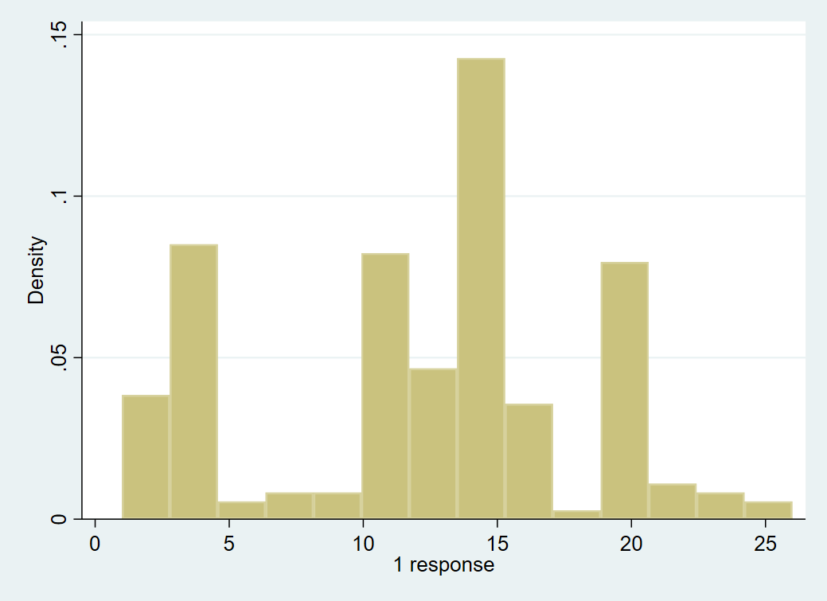

Response 2:

Among all workers in the U.S., how many times more (e.g. "1.5 times", "3 times", or "10 times") do you think a worker in the top 10% earn relative to someone in the middle of the earnings distribution?

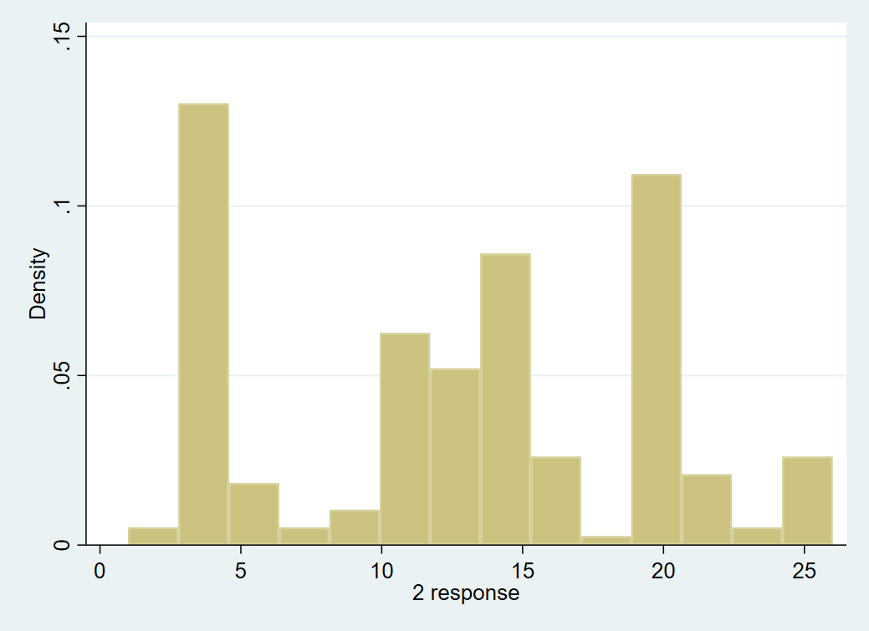

Response 3:

Did you, honestly, remember the answer to the question "How high is the labor share?" from earlier this term in our GEE class?

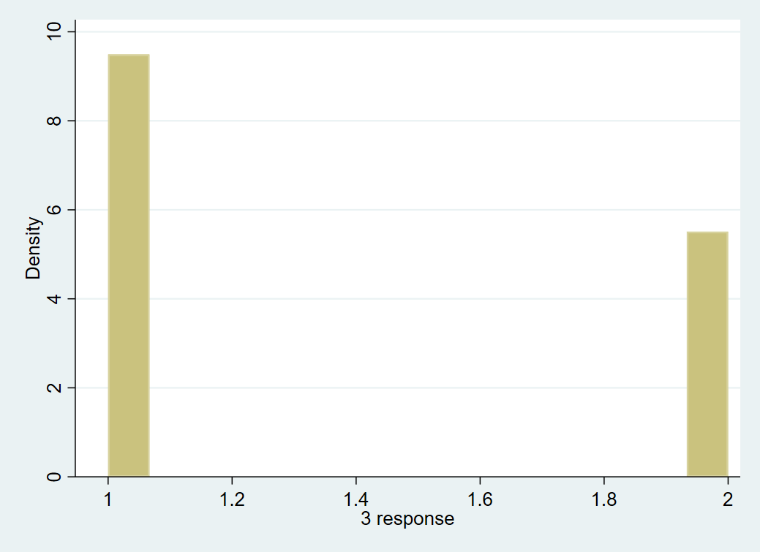

Response 4:

Do you think inequality among capitalist (i.e., only among those who own capital, not among those who are employed) has increased since 1980?

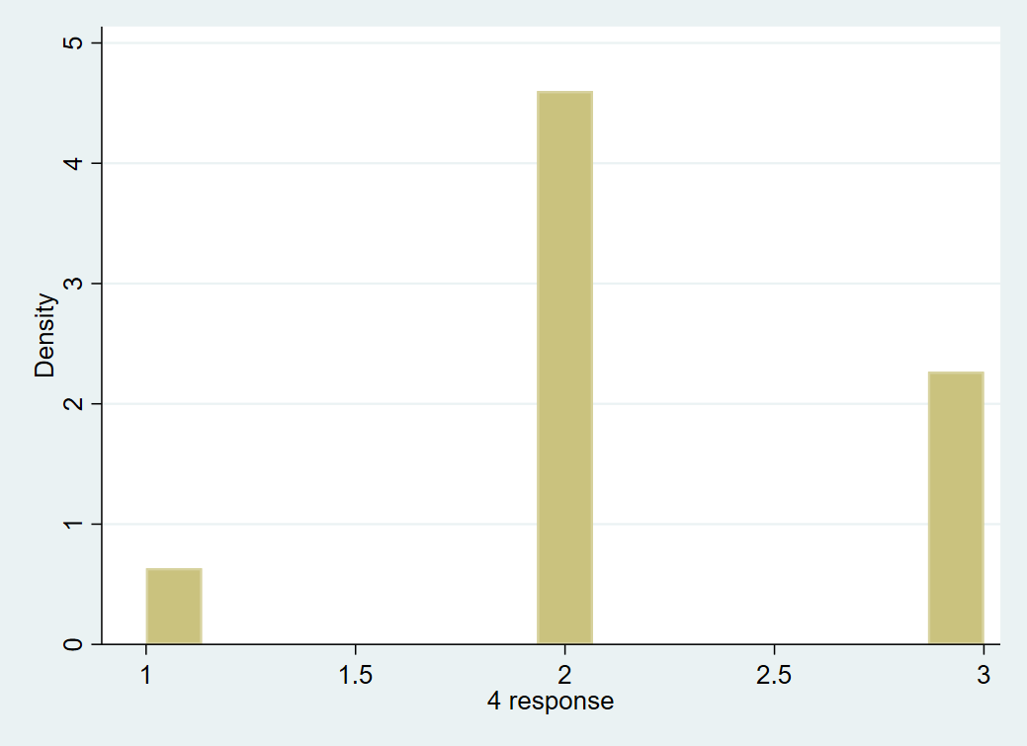

Response 5:

Do you think inequality among workers (i.e., only among those who work, not among those who earn capital rents and profits) has increased since 1980?

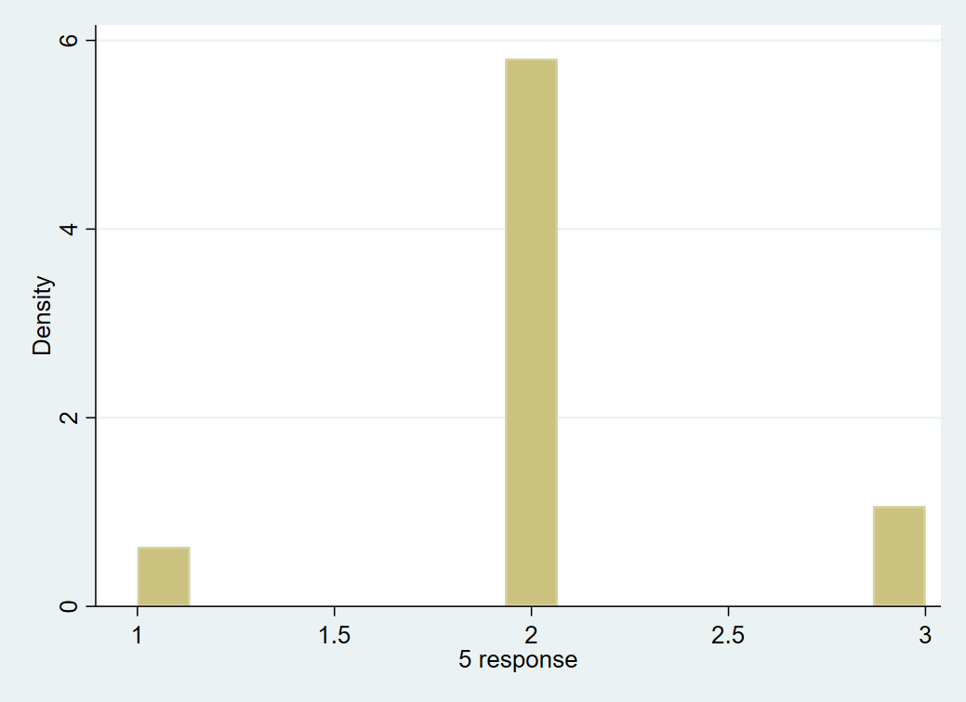

Response 6:

Do you think inequality between workers and capitalist has increased since 1980, i.e. has the labor share decreased since then?

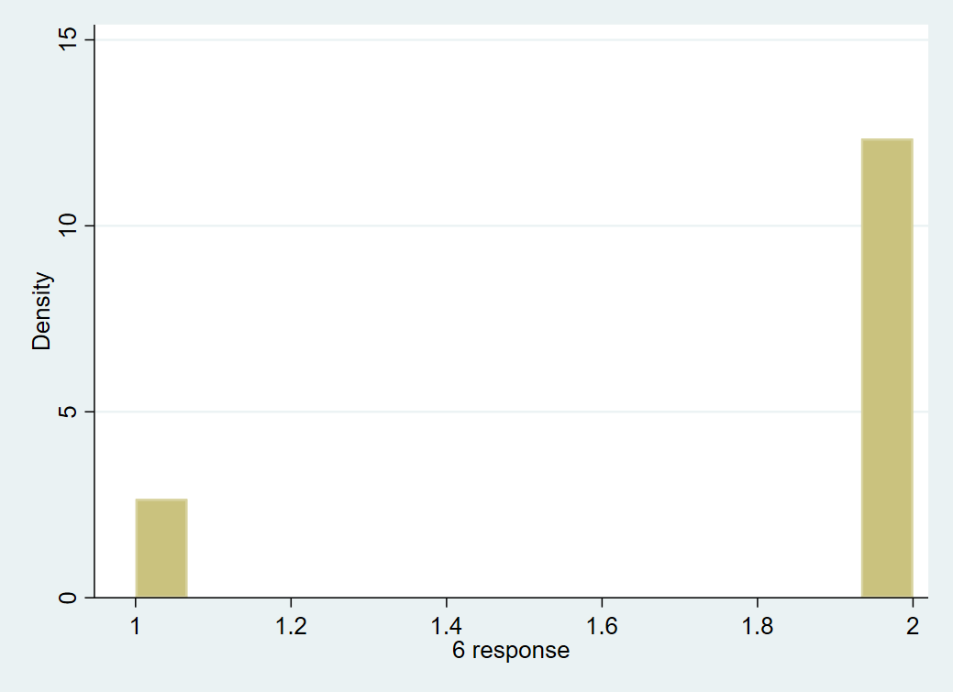

Response 7:

How high (from 0% to 100%) do you think the U.S. labor share is? The labor share is defined as the part of national income that goes to labor (workers, managers, and the self-employed) in the form of wages, salaries, bonuses, and nonpay benefits such as pensions and healthcare. In other words, the labor share is the part of national income that does not go to business owners and investors in the form of capital returns or profits.

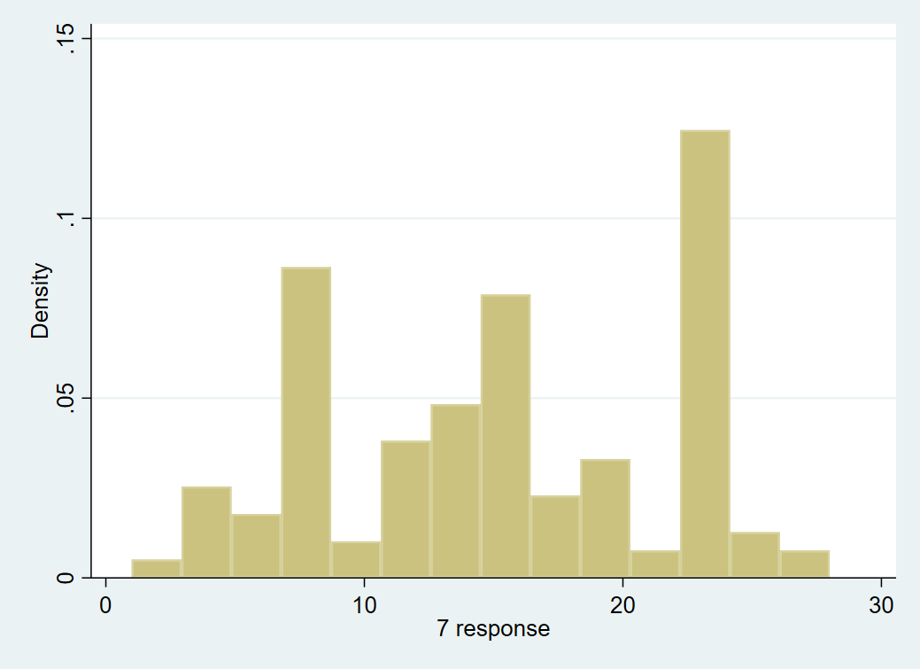

Response 8:

Is rising income inequality a serious problem that we should do something about?

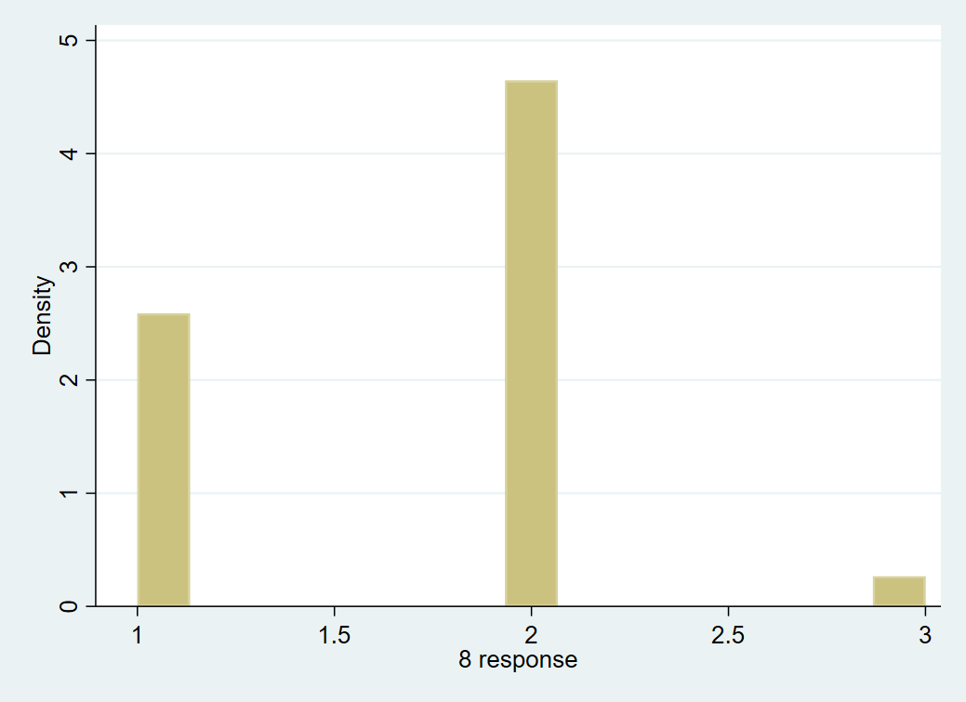

Response 9:

Over your lifetime, until now and into the future, do you think of yourself as mostly in favor of free markets or mostly in favor in government interventions in markets?

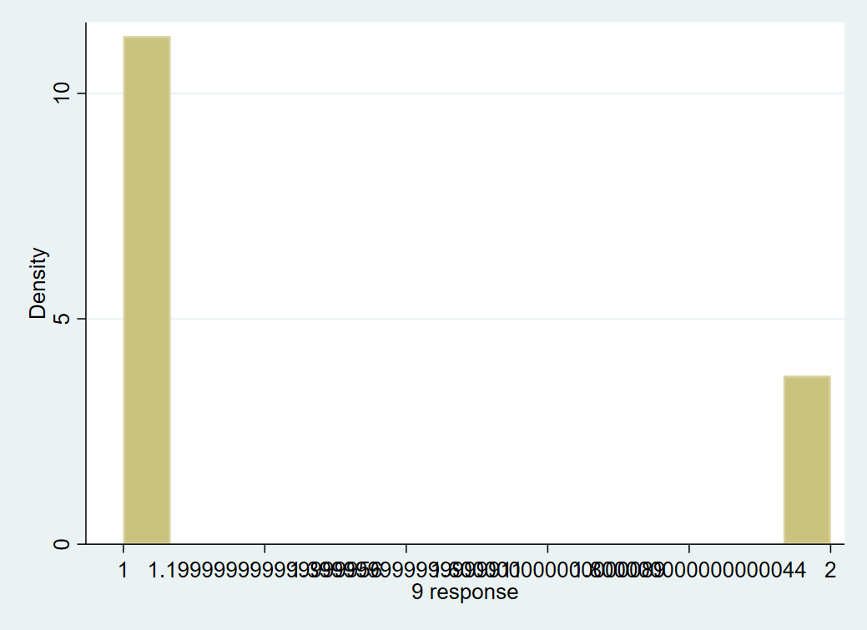

Response 10:

Over your lifetime, until now and into the future, do you think of yourself mostly as a worker or mostly as a capitalist?

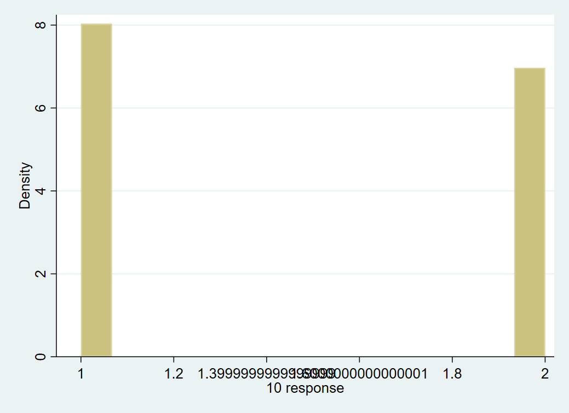

* Question 3

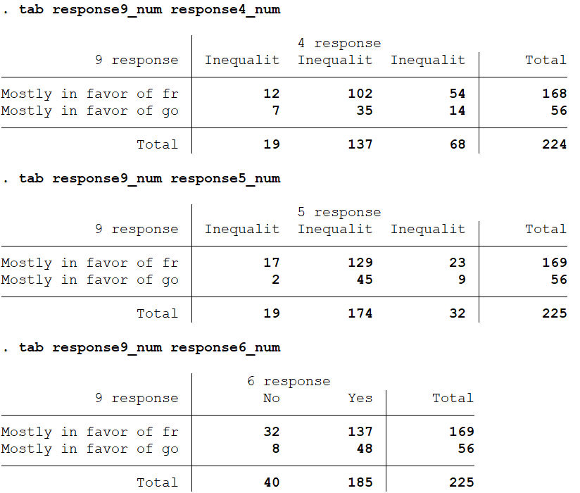

Clearly people who in the vast majority think that inequality has increased also seem to favor free markets. A sort of fairness perception, rather than a helplessness. The same people who favored free markets also tended to guess that the upper and middle classes were fewer times as rich as the bottom decile, in questions 1 and 2. Thus, suggesting that they also believe in upward mobility.

* Question 4:

The R-squared for this model, is roughly 8% of explanatory power.

Response 8 is the most significant explanatory variable of the outcomes of Question 9, at the 5% significance level.

It suggests that people who believe increasing inequality in markets is a problem, also strong favor government intervention in markets, and vice-versa.

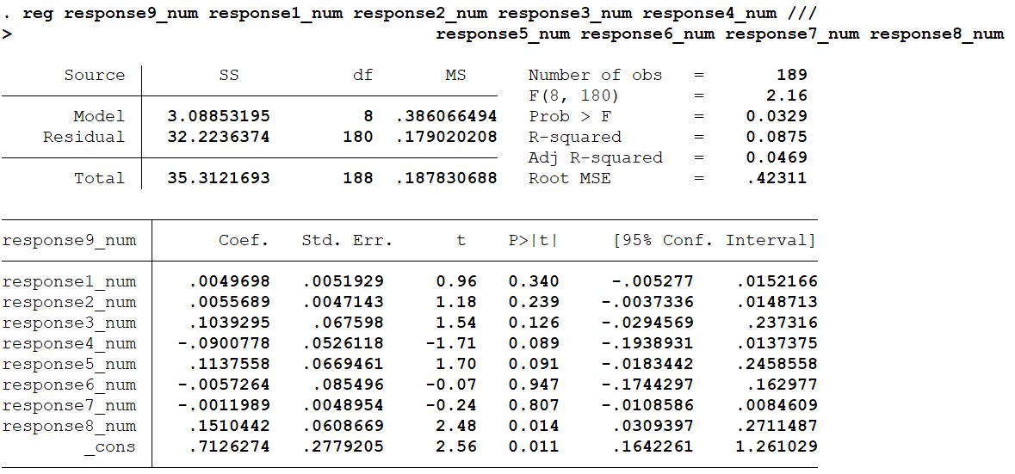

This paper concludes that peoples perceptions with regards to inequal distributions of income strongly affects their financial beliefs, and can in turn affect financial markets.